“Sometimes when you’re in a dark place you think you’ve been buried, but actually you’ve been planted.” ~ Christine Caine  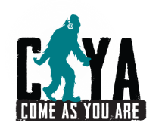  “If you believe in yourself anything is possible.”  #SasquatchApproved Messages of Hope  www.cayacoalition.org | “Sometimes when you’re in a dark place you think you’ve been buried, but actually you’ve been planted.” ~ Christine Caine  “If you believe in yourself anything is possible.”  #SasquatchApproved Messages of Hope  www.cayacoalition.org
“Sometimes when you’re in a dark place you think you’ve been buried, but actually you’ve been planted.” ~ Christine Caine  “If you believe in yourself anything is possible.”  #SasquatchApproved Messages of Hope  www.cayacoalition.org | “Sometimes when you’re in a dark place you think you’ve been buried, but actually you’ve been planted.” ~ Christine Caine  “If you believe in yourself anything is possible.”  #SasquatchApproved Messages of Hope  www.cayacoalition.org

