“You can’t change one moment of your past, but you can change your whole future.” -- unknown  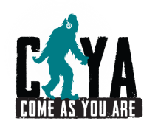  “If you believe in yourself anything is possible.”  #SasquatchApproved Messages of Hope  www.cayacoalition.org | “You can’t change one moment of your past, but you can change your whole future.” -- unknown  “If you believe in yourself anything is possible.”  #SasquatchApproved Messages of Hope  www.cayacoalition.org
“You can’t change one moment of your past, but you can change your whole future.” -- unknown  “If you believe in yourself anything is possible.”  #SasquatchApproved Messages of Hope  www.cayacoalition.org | “You can’t change one moment of your past, but you can change your whole future.” -- unknown  “If you believe in yourself anything is possible.”  #SasquatchApproved Messages of Hope  www.cayacoalition.org

